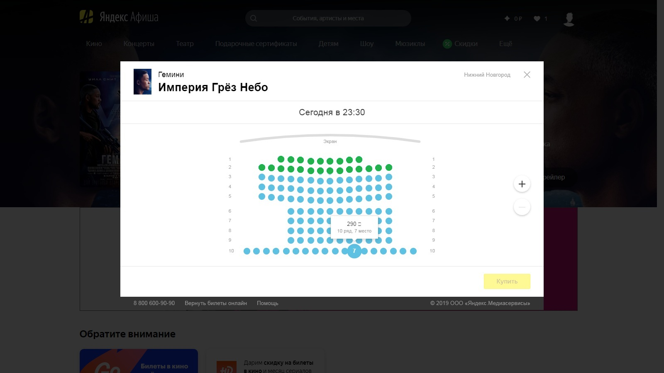

#place

#rows,  
 row(1,2 ….n)

#row-num

#row-line

#ecran

#ecran-wrapper

#arena

#date-time

#myEventPlace

#myHeader

#myDescription

#myModal

#myOverlay